# Magi Market Check taking guidelines:

* Checks cannot be used on Purchases under $10.00
* Checks cannot be written and accepted for more than the purchase amount
* Checks should not be accepted that are starter checks, unnumbered checks, or non-personalized checks

**Sample Starter Check:** If there is no Bank Name or Personalized Customer Name listed – We cannot accept these cheeks in the Magi Market

Check must be numbered

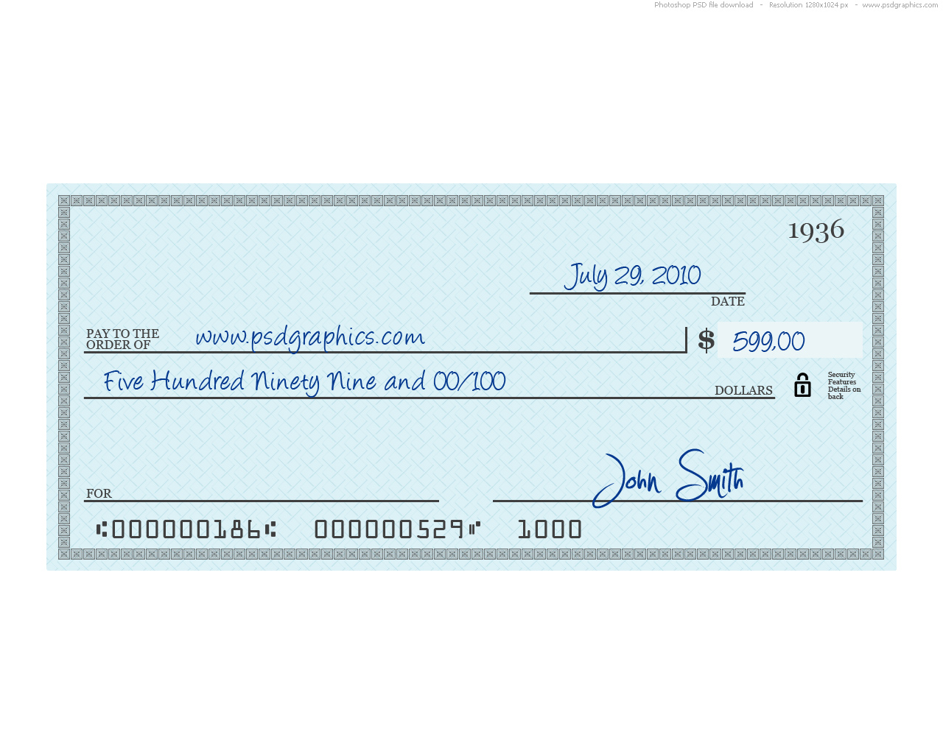

Gate City Bank  
500 West Broadway   
Minot, ND 58701

John Smith  
1500 West Barker Ave.  
Minot, ND 58701

Bank Routing number Account #

**Examine the Check:**

Carefully examineevery personal check for the following information:

* Personalization - The customer's complete name and address must appear on the check
* Check License – verify name on photo identification matches check. Write the license number on the check - If the number is printed on the check, circle it neatly then accept the check.
* Payee - "Pay to the Order of" must indicate Magi Market or Minot High School
* Date - The check date must be current.  Do not accept post- or future-dated checks
* Dollar amounts - Both the written and numeric amounts must match
* Customer Signature - The check should be signed
* Bank I.D. numbers - The check must have a bank identification number, or routing transit number, that runs across the bottom, along with the customer's account number

**Check Worksheet**

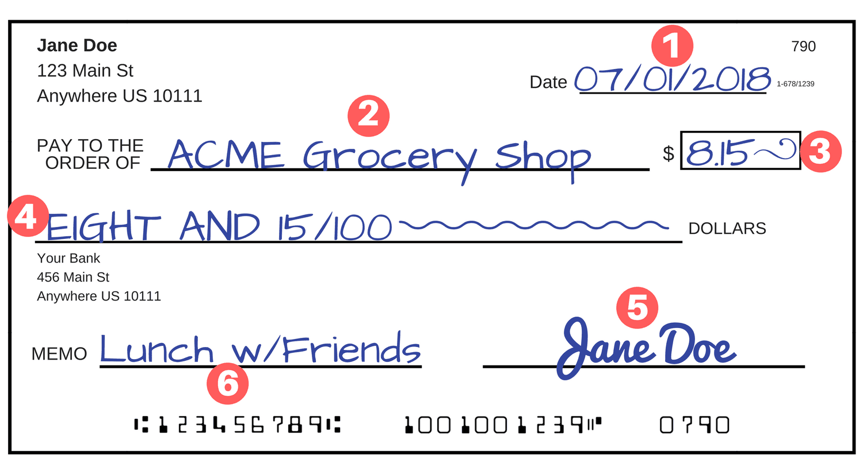

17



Use the information on the first page, or the check above to answer the following questions.

1. What is the bank name found above? Circle it above.
2. What is the check number of the check?
3. Who is the check written too (payee) on the check above?
4. When was the check written?
5. If you write a check for $85.22 how would you write the written amount on the check?

1. What is the account number for the customer from this check?
2. Circle the bank's routing number on the check above
3. What is the memo field used for and is it required?
4. Would you accept the following check? Why or why not?

